# **Specification Document**

|  |  |  |
| --- | --- | --- |
| Full Name | Date | Version |
| Raeesah Khan | 30 September 2024 |  |

# **Scope:**

This website was built to allow users to get to know the website owner their interests, hobbies and a gallery displaying images. The homepage is the main page it has an intro and links to the other pages.

# **User Story:**

* As a user, I want to access the different sections of the website , so that I can learn more about the website owner.
* As a user, I want to access the website on various devices, so that I can enjoy viewing the website on any device.

# **Use Case Diagram:**

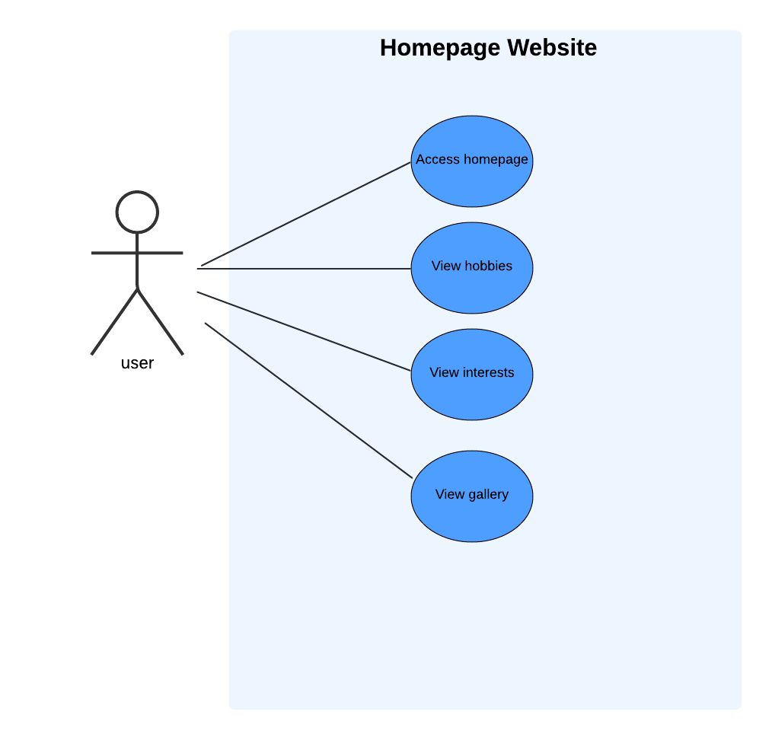

Figure 1- Use-Case diagram

# **Use-Case:**

The system allows users to navigate between different sections of the website. Users can access the homepage, which provides a description and links to additional pages detailing hobbies, interests, and a gallery to display related images.

# **Functional Requirements:**

* Display a brief description about the website owner.
* Provide navigation links to the Hobbies, Interests, and Gallery pages.
* List various hobbies and interests with descriptions and relevant images.
* Showcase images related to hobbies and interests to display in the gallery.

# **Non-Functional Requirements:**

* The website should be user-friendly and easy to navigate for users.
* The website should be accessible, responsive on various devices (desktop and mobile).
* The website should load within 15 seconds for optimal user experience.

# **Appendix:**

* https://www.w3schools.com/howto/howto_css_images_side_by_side.asp
* https://www.w3schools.com/html/html_emojis.asp
* https://www.w3schools.com/howto/howto_js_navbar_sticky.asp
* <https://www.w3schools.com/howto/howto_js_scroll_to_top.asp>